Remote control by using Telnet connection

The screenshot of the commands and responses are as follows,

After the command '*RST' and '*CLS' we could find that the signal generator is reset.

After the command 'SYST:SERR?' we could get the respond that there is no error.

There's on observing respond after the command which the title is 'BB:ARBitrary:TSIGnal:RECTangle:' with unknown reasons.

After the command 'FREQuency 100000000' and 'LEVel -25', we could find that on the screen of signal generator, the frequency of signal was set to 100MHz, and the signal level was set to -25dB.

After the command 'BB:ARBitrary:STATe 1' and 'OUTPut:STATe 1', we could find the signal wave on the screen of oscilloscope.

Time domain measurement with PyVisa python program

According to the file tdanalysis.py, we could find that the set generator signal frequency is 100MHz, the set attenuator attenuation value is 10 dB, the time horizontal scale in the oscilloscope is 5ns.

After running the program, the screenshot (photograph) of the result could be seen as follows,

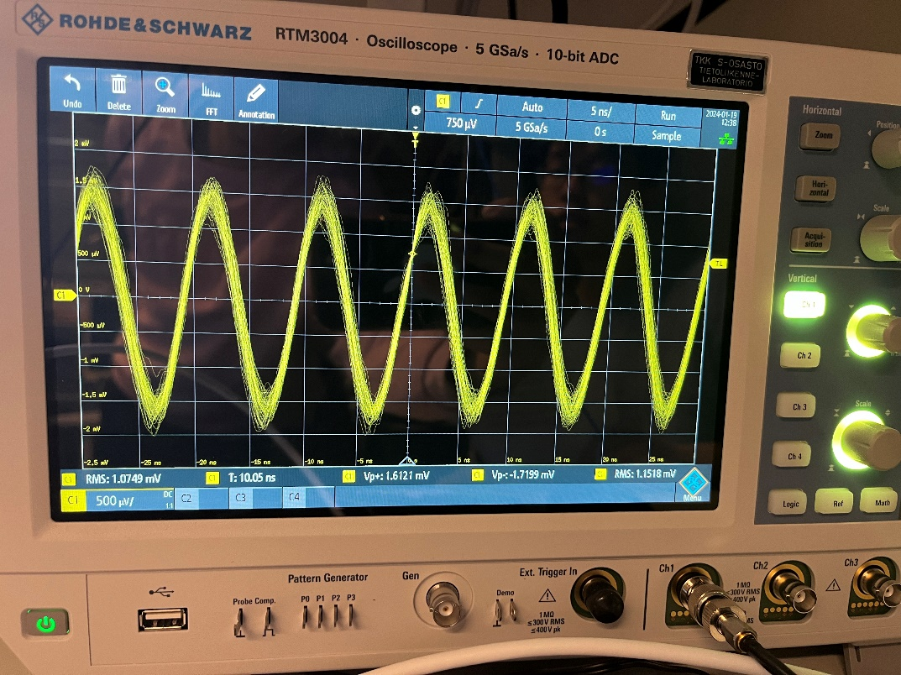

We could see 23/4 signal periods in the screenshot.

Changing the code such that the signal generator generates 40 MHz sinus signal, we could see the result as follows,

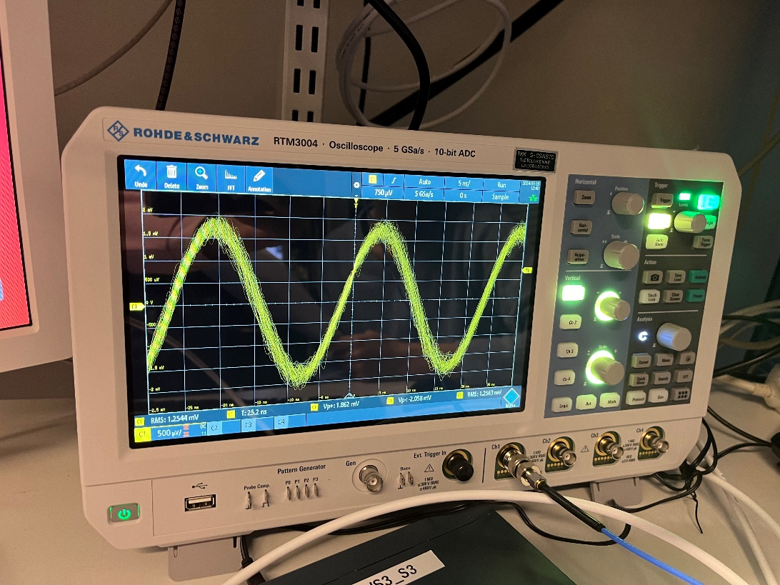

We could see that the amount of signal periods changed to 9/4.

Frequency domain measurement with PyVisa python program

When the values are the default value in the program (attenuator attenuation value equals to 10dB, signal power level of generator equals to -10dBm), theoretically, if we could ignore the cannel transmission loss, the receive signal power should be -20dBm.

But we could see the result from experiment that the receive signal power is -50dBm.

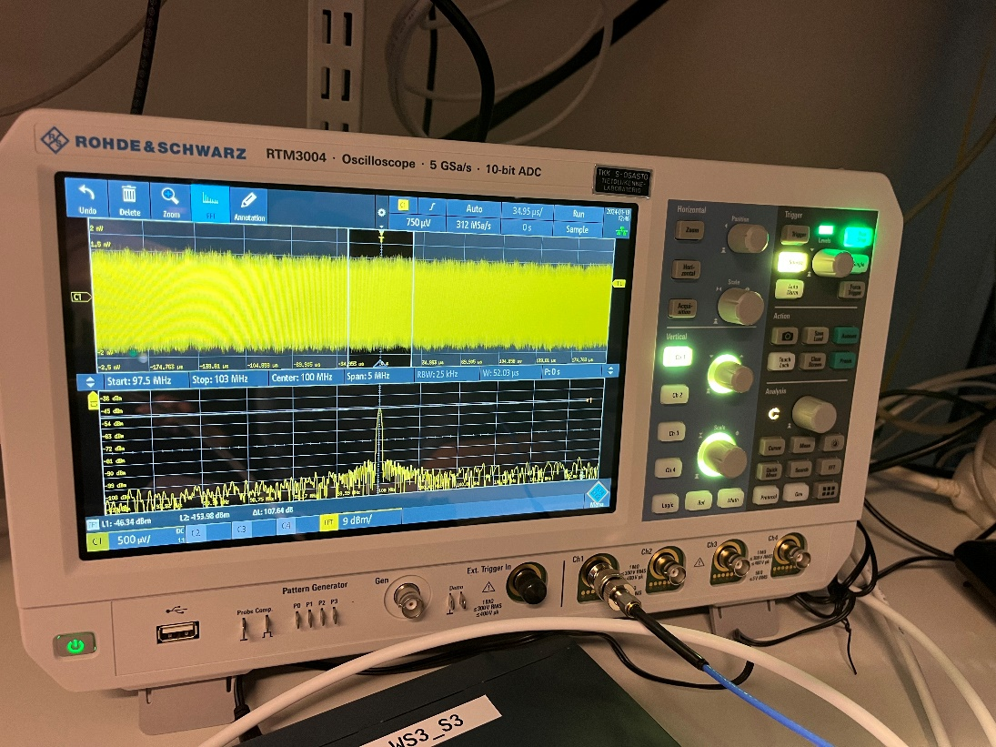

Changing the attenuator values to 15dB, we could find the result as follows, the receive signal level is about -54Bm.

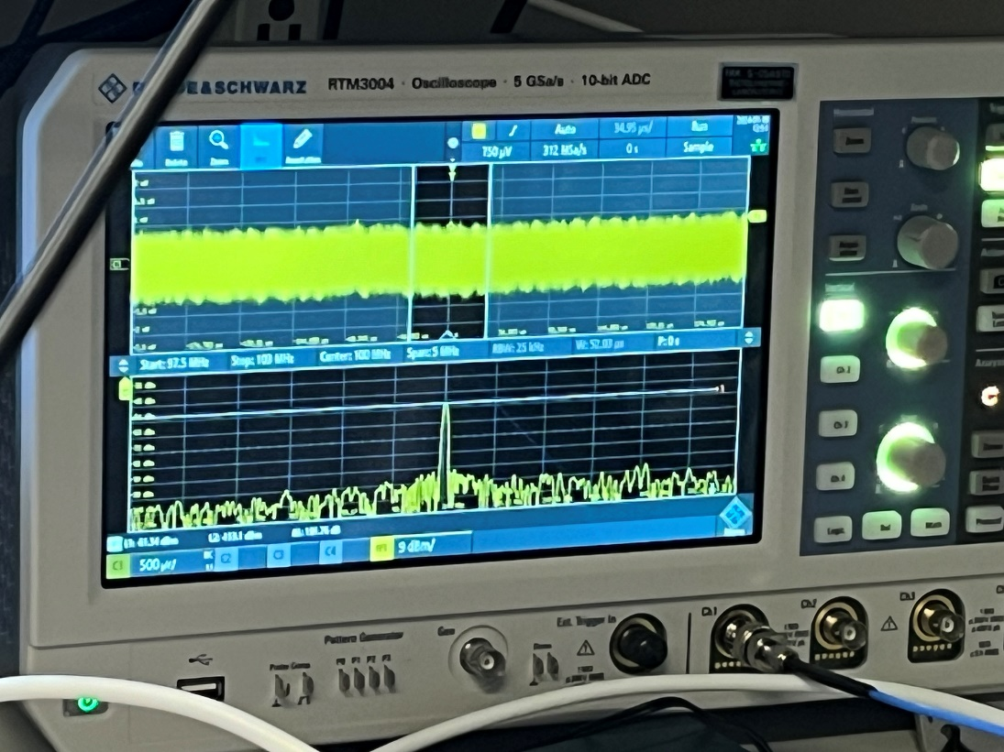

Changing the attenuator values to 20dB, we could find the result as follows, the receive signal level is about -60dBm,

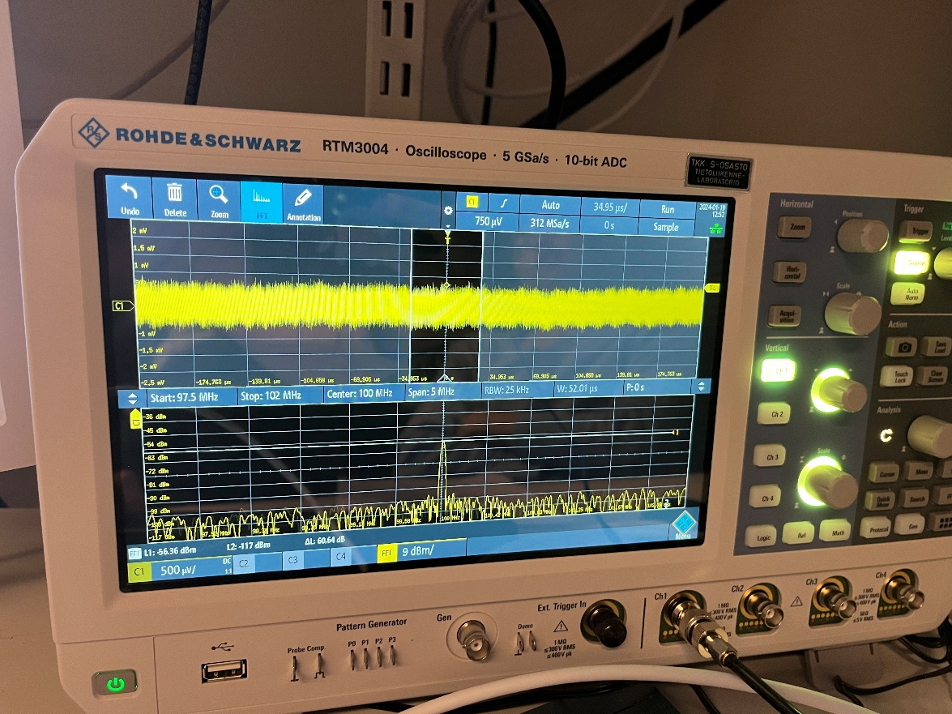

Changing the attenuator values to 25dB, we could find the result as follows, the receive signal level is about -64dBm,

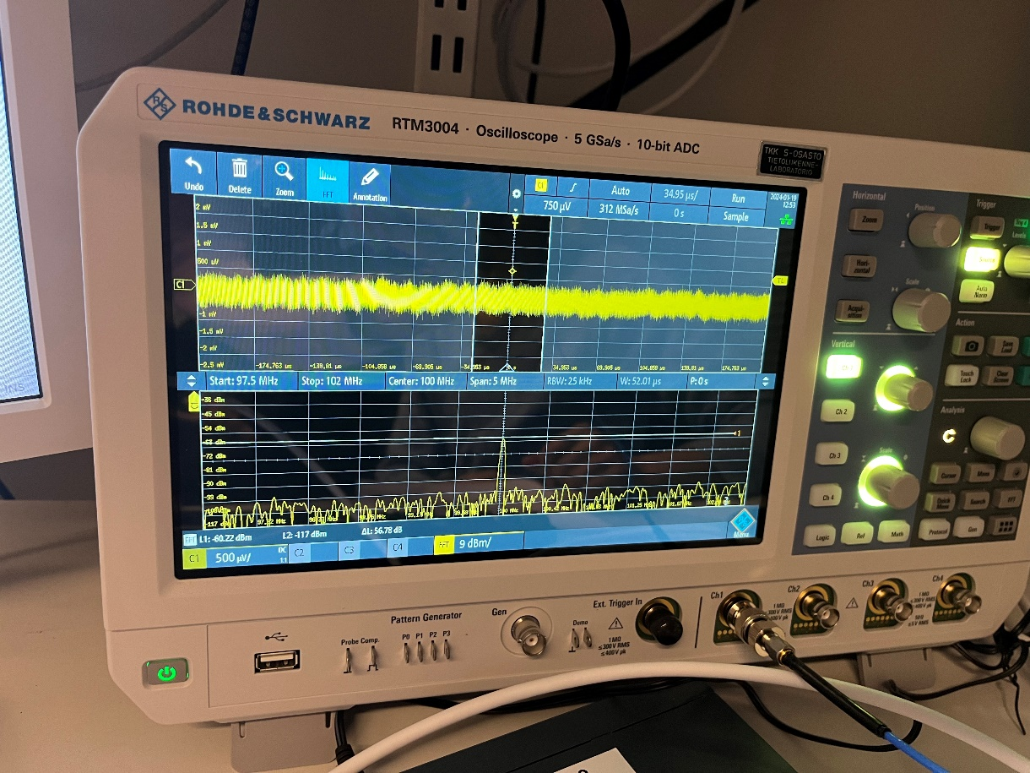

Changing the attenuator values to 30dB, we could find the result as follows, the receive signal level is about -70dBm,

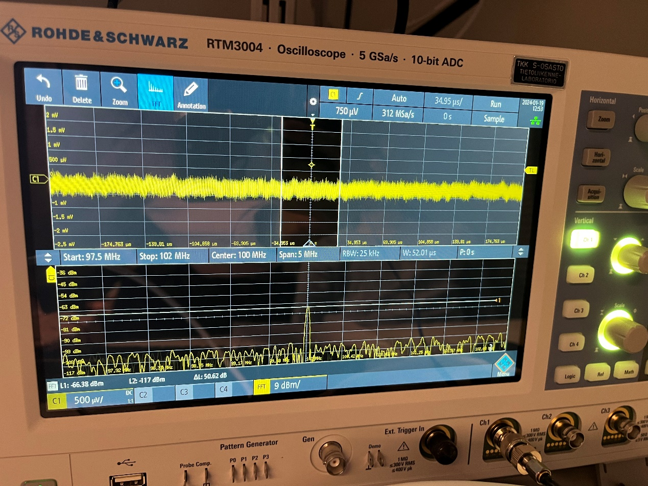

We could get the table containing the theoretical estimated signal levels at the oscilloscope and the measured signal powers as follows,

|  |  |  |  |  |  |
| --- | --- | --- | --- | --- | --- |
| Attenuator values/dB | 10 | 15 | 20 | 25 | 30 |
| Theoretically received signal power/dBm | -20 | -25 | -30 | -35 | -40 |
| Received signal power/dBm | -50 | -54 | -60 | -64 | -70 |

According to the theoretically values and the actual values, we could judge that the loss on signal pass is about 30dB.